Skill 8 - Lesson 02 Lab - Configuring Router Interfaces
Building and Configuring the Cafe-RT1 Topology Baseline & Interface Activation
1. Lab Topology & Overview
This deployment manual details how to reconstruct the point-to-point network topology inside Cisco Packet Tracer consisting of one Cisco Router (Cafe-RT1) connected directly to an Edge Switch (Cafe-SW1) via a single Ethernet link. Follow the step-by-step design rules to select, interconnect, and apply security controls to the hardware stack.
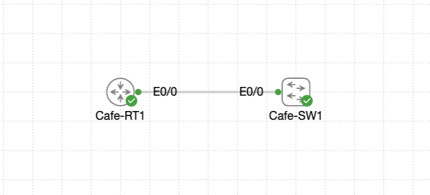
Administrative Access Credentials
Router Console / VTY Channel: | cisco / cisco
Local System Username: | cisco
Local System Password: | cisco
Privileged Access Enable Secret: | CrC0ffee!

2. Designing the Layout in Cisco Packet Tracer
1. Provision the Devices: Open Cisco Packet Tracer. Navigate to the Network Devices panel at the bottom left. Select Routers and drag a Cisco ISR 4331 or generic 2911 router onto the logical workspace. Click on the device label beneath it and rename it to Cafe-RT1.
2. Provision the Switch: Go back to the Network Devices panel, select Switches, and add a Cisco Catalyst 2960 switch into the workspace. Rename this device to Cafe-SW1.
3. Establish the Cable Medium: Select the Connections icon (represented by an orange lightning bolt). Choose the solid black Copper Straight-Through cable. Click once on Cafe-RT1 and map the cable connection to port Ethernet0/0. Stretch the line across and connect it to port Ethernet0/0 on Cafe-SW1.
3. Command Line Interface (CLI) Instructions
Task 0 - Apply the Router Baseline
Secure the blank router so the field crew can connect without compromising the site.
Cafe-RT1> enable
Cafe-RT1# conf t
Cafe-RT1(config)# hostname Cafe-RT1
Cafe-RT1(config)# username cisco secret cisco
Cafe-RT1(config)# line con 0
Cafe-RT1(config-line)# login local
Cafe-RT1(config-line)# logging synchronous
Cafe-RT1(config-line)# exit
Cafe-RT1(config)# line vty 0 4
Cafe-RT1(config-line)# login local
Cafe-RT1(config-line)# transport input ssh telnet
Cafe-RT1(config-line)# exit
Cafe-RT1(config)# enable secret CrC0ffee!
Cafe-RT1(config)# end
Cafe-RT1# write memory
Task 1 - Inspect Available Interfaces
Understand which hardware ports are present and their default state.
Cafe-RT1# show ip interface brief
Cafe-RT1# show interfaces description
Task 2 - Activate the LAN Interface
Bring the inside port online and document both LAN and WAN interfaces.
Cafe-RT1# conf t
Cafe-RT1(config)# interface ethernet0/0
Cafe-RT1(config-if)# description ## CoffeeHouse-LAN
Cafe-RT1(config-if)# ip address 192.168.42.1 255.255.255.0
Cafe-RT1(config-if)# no shutdown
Cafe-RT1(config-if)# exit
Cafe-RT1(config)# interface ethernet0/1
Cafe-RT1(config-if)# description ## WAN-Pending
Cafe-RT1(config-if)# shutdown
Cafe-RT1(config-if)# end
Cafe-RT1# show ip interface brief
Task 3 - Verify the Neighbor Link and Test Connectivity
Prove the router's LAN interface is connected and can reach Cafe-SW1 across the management subnet.
Cafe-RT1# show cdp neighbors detail
Total cdp entries displayed : 0
Cafe-RT1# show ip interface brief | include Ethernet0/0
Ethernet0/0 192.168.42.1 YES manual up up
Cafe-RT1# ping 192.168.42.2
Type escape sequence to abort.
Sending 5, 100-byte ICMP Echos to 192.168.42.2, timeout is 2 seconds:
...!!
Success rate is 40 percent (2/5), round-trip min/avg/max = 1/2/3 ms
Cafe-RT1# ping 192.168.42.2
Type escape sequence to abort.
Sending 5, 100-byte ICMP Echos to 192.168.42.2, timeout is 2 seconds:
!!!!!
Success rate is 100 percent (5/5), round-trip min/avg/max = 2/2/2 ms
Cafe-RT1# write memory
4. Completion Verification Checklist
• Ethernet0/0 is up/up with description ## CoffeeHouse-LAN, IP 192.168.42.1/24, and full reachability to Cafe-SW1 (192.168.42.2).
• Ethernet0/1 remains administratively down, labeled ## WAN-Pending, ready for carrier hand-off.
• Console and VTY sessions require local credentials verification, enable secret is set to CrC0ffee!, and settings are saved successfully.

